PC Network TCP/IP Configuration
LAB # 01



Spring 2024
CSE-303L Data Communication & Networks Lab

Submitted by: Ali Asghar
Registration No.: 21PWCSE2059
Class Section: C

“On my honor, as student of University of Engineering and Technology, I have neither given nor received unauthorized assistance on this academic work.”

Submitted to:
Dr. Yasir Saleem Afridi

Date:
19th March 2024

Department of Computer Systems Engineering
University of Engineering and Technology, Peshawar
CSE 303L: Data Communication and Computer Networks
Credit Hours: 1
Contact Hours: 3

LAB ASSESSMENT RUBRIC
Demonstration of Concepts | Poor (Does not meet expectation (1))  The student failed to demonstrate a clear understanding of the assignment concepts | Fair (Meet Expectation (2-3))  The student demonstrated a clear understanding of some of the assignment concepts | Good (Exceeds Expectation (4-5)  The student demonstrated a clear understanding of the assignment concepts | Score  30%
Accuracy | The student mis-configured enough network settings that the lab computer couldn't function properly on the network | The student configured enough network settings that the lab computer partially functioned on the network | The student configured the network settings that the lab computer fully functioned on the network | 30%
Following Directions | The student clearly failed to follow the verbal and written instructions to successfully complete the lab | The student failed to follow the some of the verbal and written instructions to successfully complete all requirements of the lab | The student followed the verbal and written instructions to successfully complete requirements of the lab | 20%
Time Utilization | The student failed to complete even part of the lab in the allotted amount of time | The student failed to complete the entire lab in the allotted amount of time | The student completed the lab in its entirety in the al | 20%

Lab Objectives:
- Gather information including connection, host name, Layer 2 MAC address and Layer 3 TCP/IP network address information.
- Compare network information to other PCs on the network.
- Identify tool used for discovering a computer’s network configuration.

ipconfig Command:
ipconfig is a useful command-line utility in Windows that provides information about the network configuration of your computer. Here are some key points about ipconfig:
- Basic Usage:
  - To use ipconfig, open Command Prompt or PowerShell:
    - Press Windows key + X or right-click on the Start menu.
    - Select Windows PowerShell or Command Prompt.
  - Type ipconfig and press Enter.
  - This command displays basic network information from your network adapters.

- What It Shows:
  - When used without parameters, ipconfig displays:
    - IPv4 and IPv6 addresses.
    - Subnet mask.
    - Default gateway for all network adapters.

- Additional Parameters:
  - /all: Displays the full TCP/IP configuration for all adapters (physical or logical).
  - /displaydns: Shows the contents of the DNS client resolver cache.
  - /flushdns: Clears and resets the DNS client resolver cache.
  - /registerdns: Manually initiates dynamic DNS name registration.
  - /release [<adapter>]: Releases the current DHCP configuration for specified or all adapters.
  - /renew [<adapter>]: Renews DHCP configuration for specified or all adapters.

- Practical Use:
  - Troubleshoot network issues.
  - Obtain IP address details.
  - Refresh DNS settings.
  - Release and renew DHCP configurations.

DHCP: Dynamic host control protocol:
Such protocol dynamically assigns IP to a newly connected host to a network. Problem with Static IP was that different computers connect to a network at different time, so such situation is hard to handle in case of static IP. Dynamic host control protocol solves this problem by de-allocating IP of a computer when it disconnects then that IP can be assigned to newly connected computer.

NAT: Network Address translation:
Different computers on different networks may have similar IP address, when any of these two computers try to communicate to with other computer, the other computer reply then there is confusion because so same IP of two different computer (i.e. it is harder to distinguish that which one is sender between two similar IP computers) so NAT is used to translate the addresses into a unique address.

DNS cache:
Used to store history of DNS addresses for faster communication.

Gathering TCP/IP configuration information:
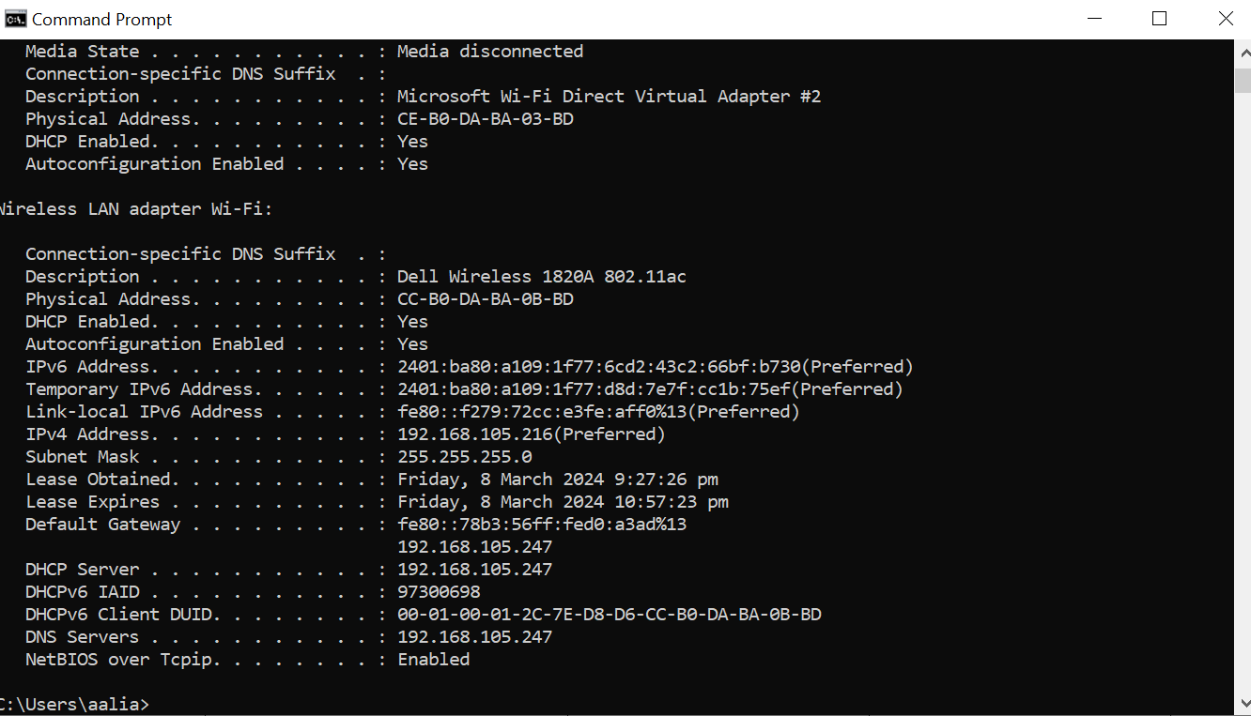

 | Computer 1 | Computer 2 | Computer 3
IP Address | 192.168.105.216 | 192.168.137.1 | 192.168.137.89
Subnet Mask | 255. 255. 255.0 | 255. 255. 255.0 | 255. 255. 255.0
Default Gateway | 192.168.105.247 | 192.168.0.1 | 192.168.137.1
DNS Address | 192.168.105.247 | 192.168.0.1 | 192.168.0.1
DHCP Address | 192.168.0.1 | 192.168.0.1 | 192.168.0.1

Answers to questions:
Difference between Fig.1 and Fig.2: In figure1 Wireless network information are shown while LAN is disconnected while in figure2 Wireless network information is shown as well as the LAN is connected.

If this computer is on a LAN, compare the information of several machines.
Are there any similarities?
Ans: Network portion of IP addresses are same and default gateway is same for Computer 2 and 3. Computer 1 is connected to a different LAN, hence it has different IP addresses and default gateway.
What is similar about the IP addresses?
Ans: Node portion of IP addresses are different while Network portion are same.

What is similar about the default gateways?
Ans: Default gateway is same for both Computer 1 and 2.

Record a couple of the IP Addresses:
Ans: 192.168.1.103 and 192.168.1.102

Notice the Physical Address (MAC) and the NIC model (Description).
Ans: MAC: CE-B0-DA-BA-03-BD NIC model: Microsof Wi-Fi Direct Virtual Adapter #2

Write down the IP addresses of any servers listed:
Ans: 192.168.1.1

Write down the computer Host Name:
Ans: DESKTOP-5AU4H87

Write down the Host Names of a couple other computers:
Ans: DESKTOP-EU3UIAH and DESKTOP-8TKL61H

Do all of the servers and workstations share the same network portion of the IP address as the student workstation?
Ans: Yes.

Based on observations, what can be deduced about the following results taken from three computers connected to one switch?
Computer 1

IP Address: 192.168.5.13
Subnet Mask: 255.255.255.0
Default Gateway: 192.168.12.1

Computer 2

IP Address: 192.168.5.5
Subnet Mask: 255.255.255.0
Default Gateway: 192.168.12.1

Computer 3

IP Address: 192.168.11.97
Subnet Mask: 255.255.255.0
Default Gateway: 192.168.12.1

Should they be able to talk to each other?

Ans: Computer 1 and Computer 2 are able to talk to each other while Computer 3 can’t talk to Computer 1 or Computer 2.

Are they all on the same network? Why or why not?
Ans: Computer 1 and Computer 2 belong to same network because network portion of their IP addresses are same while Computer 3 belongs to different network as its network portion of its IP address is different than Computer 1 and Computer 2.

